 **Greenwood College**

**Semester One Examination, 2018**

**Question/Answer Booklet**

**MATHEMATICS APPLICATIONS**

**UNIT 1**

**Section One:**

**Calculator-free**

Your name

**Time allowed for this section**

Reading time before commencing work: five minutes

Working time for this section: fifty minutes

**Materials required/recommended for this section**

***To be provided by the supervisor***

This Question/Answer Booklet

Formula Sheet

***To be provided by the candidate***

Standard items: pens (blue/black preferred), pencils (including coloured), sharpener,

correction fluid/tape, eraser, ruler, highlighters

Special items: nil

**Important note to candidates**

No other items may be taken into the examination room. It is **your** responsibility to ensure that you do not have any unauthorised notes or other items of a non-personal nature in the examination room. If you have any unauthorised material with you, hand it to the supervisor **before** reading any further.

**Structure of this paper**

|  |  |  |  |  |  |
| --- | --- | --- | --- | --- | --- |
| Section | Number of questions available | Number of questions to be answered | Working  time (minutes) | Marks available | Percentage of exam |
| Section One:  Calculator-free | 7 | 7 | 50 | 53 | 35 |
| Section Two:  Calculator-assumed | 12 | 12 | 100 | 97 | 65 |
|  | | | **Total** | 150 | 100 |

**Instructions to candidates**

1. The rules for the conduct of examinations are detailed in the school handbook. Sitting this examination implies that you agree to abide by these rules.

2. Write your answers in this Question/Answer Booklet.

3. You must be careful to confine your response to the specific question asked and to follow any instructions that are specified to a particular question.

4. Spare pages are included at the end of this booklet. They can be used for planning your responses and/or as additional space if required to continue an answer.

* Planning: If you use the spare pages for planning, indicate this clearly at the top of the page.
* Continuing an answer: If you need to use the space to continue an answer, indicate in the original answer space where the answer is continued, i.e. give the page number. Fill in the number of the question that you are continuing to answer at the top of the page.

5. **Show** **all your working clearly**. Your working should be in sufficient detail to allow your answers to be checked readily and for marks to be awarded for reasoning. Incorrect answers given without supporting reasoning cannot be allocated any marks. For any question or part question worth more than two marks, valid working or justification is required to receive full marks. If you repeat any question, ensure that you cancel the answer you do not wish to have marked.

6. It is recommended that you **do not use pencil**, except in diagrams.

7. The Formula Sheet is **not** to be handed in with your Question/Booklet.

Section One: Calculator-free 35% (53 Marks)

This section has**seven (****7)** questions. Answer **all** questions. Write your answers in the spaces provided.

Working time: 50 minutes.

Question 1 (8 marks)

Four measurements are recorded on a production line at hourly intervals and then used to calculate the values of $P_{1}, P_{2}$ and $P_{3}$. These values are then reported to a supervisor. The formulas used are shown below.

$$P_{1}=\frac{3}{2}a^{2}+b^{2}, P_{2}=b\sqrt{c}+\frac{60}{d}, P_{3}=100P_{1}-{10P}_{2}.$$

During one round of measurements, the values recorded were

$$a=4, b=3, c=25, d=15.$$

Calculate the value of

(a) $P_{1}$. (3 marks)

(b) $P_{2}$. (3 marks)

(c) $P_{3}$. (2 marks)

Question 2 (9 marks)

A mandarin farmer employed casual labourers for fruit picking. The business pays casual labourers an hourly rate of $20 per hour, with time and a half being paid for any weekend work.

One week, a casual labourer worked 6 hours on Tuesday, 5 hours on Wednesday, 4 hours on Saturday and 3 hours on Sunday.

(a) How much did the casual labourer earn

(i) on Tuesday? (1 mark)

(ii) over the weekend? (2 marks)

(iii) during the whole week? (2 marks)

(b) Calculate the **increase** in earnings the following week, if the casual labourer worked the same days but for 5 hours each day. (2 marks)

(c) The business makes a superannuation contribution of 9.5% of weekly earnings for casual labourers. Calculate the weekly superannuation contribution for a casual labourer who earns $880 per week. (2 marks)

Question 3 (8 marks)

The spreadsheet below shows some example costs ( $C$ in $) to transport a package by air between two locations. The cost depends on the weight of the package ( $W$ kg) and the amount by which the longest dimension of the package exceeds one metre ( $E$ m).

|  |  |  |  |  |  |
| --- | --- | --- | --- | --- | --- |
| $C$ ($) | | $E$ (m) | | | |
| 0 | 1 | 2 | 3 |
| $W$ (kg) | 10 | 30 | 42 | 58 | 78 |
| 20 | 60 | 82 | 108 | 138 |
| 30 | 90 | 122 | $$A$$ | 198 |
| 40 | 120 | 162 | 208 | 258 |

(a) Use the spreadsheet to determine $C$ when

(i) $E=1$ and $W=40$. (1 mark)

(ii) $W=10$ and $E=3$. (1 mark)

The cost is calculated using the formula $C=3W+2E^{2}+EW$.

(b) Show use of the above formula to determine the value of $A$ in the spreadsheet. (3 marks)

(c) Calculate the cost of transporting a 15 kg package that has a longest dimension of 3 m.

(3 marks)

Question 4 (11 marks)

(a) Express 3[ 3 11 -6 ] – 2[ 1 -5 4 ] as a single matrix. (3 marks)

(b) Matrices $D$ and $E$, with dimensions $5×3$ and $6×5$ respectively, can be multiplied together. State the dimensions of the product, briefly justifying your answer. (2 marks)

(c) Calculate $\left[\begin{matrix}2 & -1\end{matrix}\right]×\left[\begin{matrix}4 & 0 & 6 \\ 0 & -5 & 3\end{matrix}\right]$. (2 marks)

(d) Determine the values of the constants $a, b$ and $c$ given that $10I+a\left[\begin{matrix}-2 & 9 \\ 1 & b\end{matrix}\right]=\left[\begin{matrix}c & 27 \\ 3 & 31\end{matrix}\right]$, where $I$ is the $2×2$ identity matrix. (4 marks)

Question 5 (7 marks)

(a) Two similar right-triangles (not drawn to scale) are shown below.

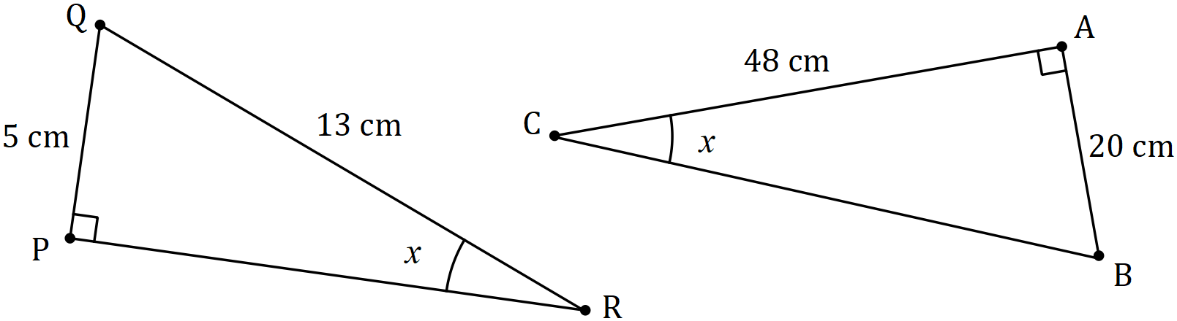

(i) Determine the lengths of the sides $BC$ and $PR$. (3 marks)

(ii) The area of $⊿ABC$ is $k$ times greater than the area of $⊿PQR$. State the value of $k$.

(1 mark)

(b) A right-triangle has sides of lengths 20 cm, 29 cm and 21 cm.

(i) Between which two sides is the right-angle? (1 mark)

(ii) Calculate the area of the triangle. (2 marks)

Question 6 (5 marks)

Summary information about a small portfolio of shares is shown in the table below.

|  |  |  |  |  |
| --- | --- | --- | --- | --- |
| Share code | Number of shares | Current market price | Last dividend per share | Price-Earnings ratio |
| YBB | 200 | $14.00 | $0.45 | 16.5 |
| ZCC | 1000 | $3.50 | $0.12 | 11.0 |

(a) Determine the total dividend of the portfolio, based on the last dividend paid. (2 marks)

(b) The investor sells all the YBB shares at the current market price, paying a 2% commission for brokerage. Determine how much the investor receives. (3 marks)

Question 7 (5 marks)

The rate of the Goods and Services Tax (GST) varies from country to country. In Australia it is 10% but in Thailand it is only 7% whilst in Sweden it is 25%.

(a) Determine the amount of GST that must be added to goods valued at $300 in Sweden.

(1 mark)

(b) The price of a TV set in Thailand is $400, excluding GST. Calculate the GST inclusive price. (2 marks)

(c) In another country, a $20 CD costs $23 when GST is included. Determine the rate of GST in this country. (2 marks)

Supplementary page

Question number: _________

Supplementary page

Question number: _________